**Course Project: Prediction of infrastructure damage level caused by Gorkha Earthquake in Nepal**

Team - Kavya Shirke, Ruy Roa, Abhinav Singh, Abhimanyu Soni & Daniel Roca

**Introduction**

 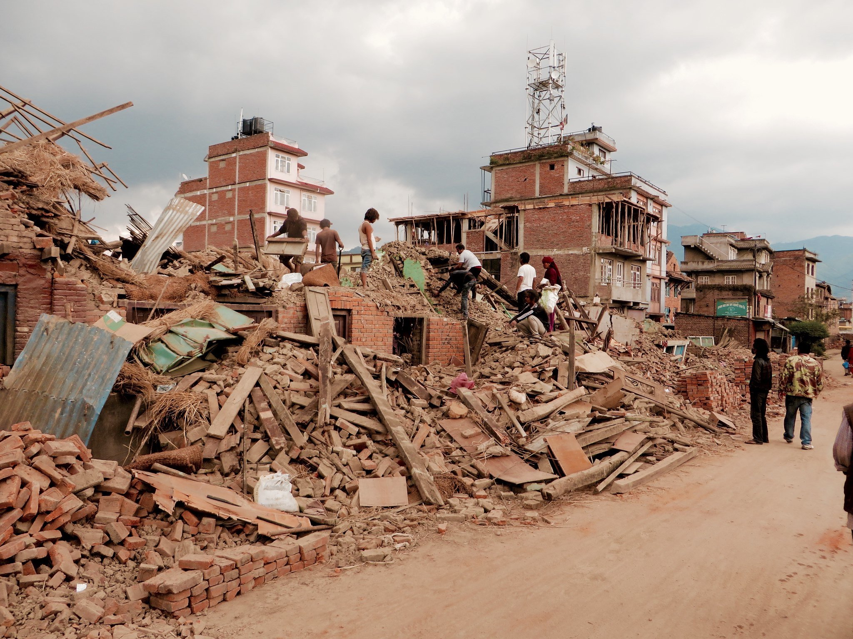

The 2015 Gorkha earthquake in Nepal destroyed critical infrastructure, such as bridges or tunnels, and consequently 14 out of 75 nepalese districts were declared crisis-hit and in these fourteen districts, more than 500,000 residential buildings, 5000 school and 500 health facilities simply collapsed. The overall financial loss amounts to $7 billion USD. Within this project, we want to predict the damage level of infrastructure during catastrophes such as earthquakes, and thereby, potentially contribute to a faster and more secure rescue response. The prediction will be based on features regarding location and structure of affected buildings.

**To obtain the data**

The project is based on data about the 2015 Gorkha earthquake in Nepal, provided by Kathmandu Living Labs and the Central Bureau of Statistics of the Government of Nepal. According to DRIVENDATA, the dataset is one of the largest postdisaster datasets ever collected and contains information about earthquake impacts, household conditions, and socio-economic demographic statistics.

The dataset is available in the following webpage:

<https://www.drivendata.org/competitions/57/nepal-earthquake/>

**Data Exploration**

We will begin with exploratory data-analysis to understand the features of the dataset and then pre-process it for the model-building process. For example, we will examine the balance of the given dataset (i.e., we may have many more examples of one class than of other classes), and whether there are missing values or mislabelled data points present.

**Data preprocessing tasks before starting the project**

Encoding categorical variables

Machine learning models require all input and output variables to be numeric. Hence, we will encode our categorical data to numbers. In this project, we will use the categorical encoders library in order to convert the variables into binary columns.

Data scaling

Oftentimes, continuous variables in datasets are based on different scales. Based on the type of model, we will normalize the data to ensure similar ranges of all variables. To achieve this, we will use the StandardScaler function.

Dimensionality reduction

The performance of machine learning algorithms can degrade with too many input variables and make the task of predictive modeling challenging and complex. Hence, we will use dimensionality reduction techniques like PCA and LDA to reduce the number of input variables in our dataset.

**Task for the project**

After this preprocessing steps, the project guidelines are:

1. Apply all approaches taught in the course and practiced in lab sessions (Decision Trees, Bagging, Random forests, Boosting, Gradient Boosted Trees, AdaBoost, etc.) on this data set. The goal is to predict the target variable: level of damage (1, 2 or 3 to the infrastructure).
2. Compare performances of all these models (for example, in terms of the weighted-f1 scores you can output).
3. Conclude about the most appropriate approach on this data set for the predictive task.
4. Write a report that addresses all these guidelines with a maximal page number of 5 (including figures, tables and references). We will take into account the quality of writing and presentation of the report.